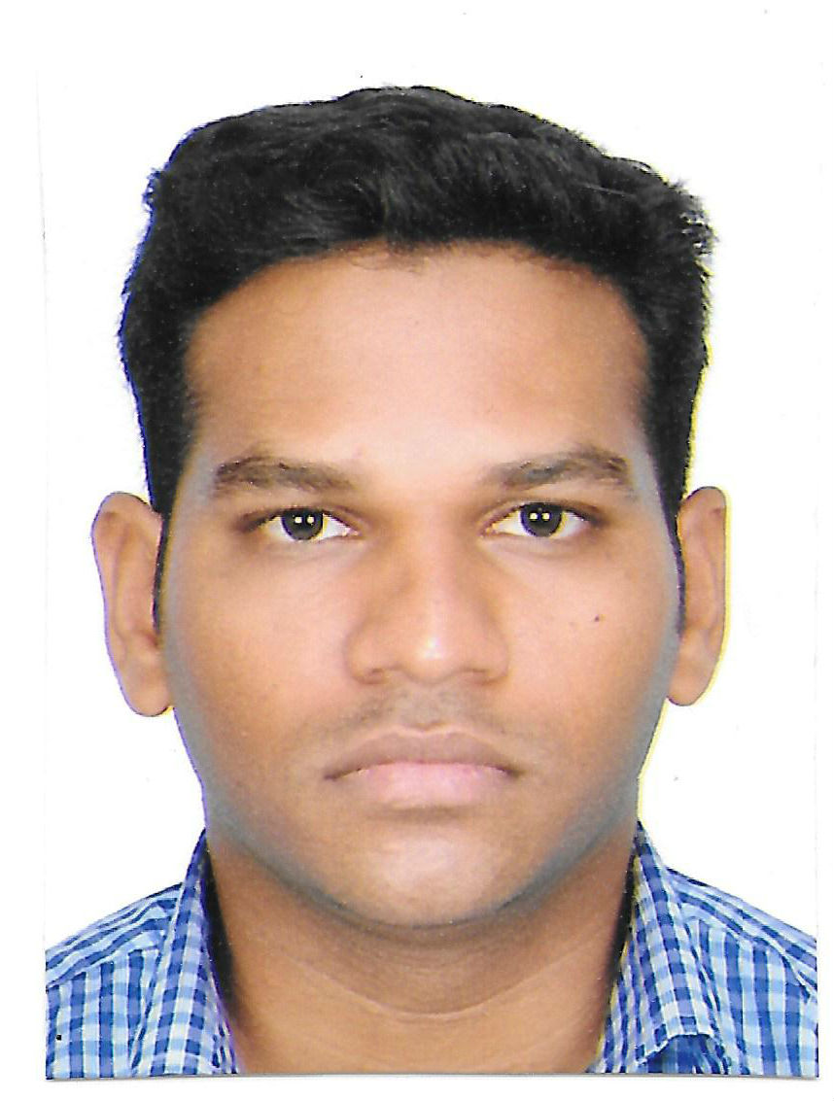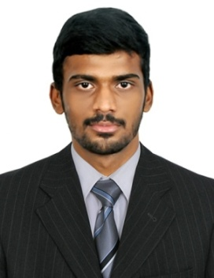

**NIJANTHANRAJASEKARAN**

**Ph. No**: +91-8760641235

**Email**: nijanthansap@gmail.com

To work for your company as SEO Analyst and make a positive contribution by fully utilizing my education and experience.

**Professional Experience**

* Company : **Webapplestar Software Solution, Chennai**
* Designation : Sr. Digital Marketing Executive
* Nature of job : SEO Analyst
* Duration : January 2013 to Jan 2017
* Company : **Axes3 Technologies, Chennai (Both Same Company)**
* Designation : Campaign Manager
* Nature of job : SEM Manager
* Duration : April 2017 to JULY 2017
* Company : **Syspeak solutions, Chennai (Both Same Company)**
* Designation : Campaign Manager
* Nature of job : SEM Manager
* Duration : August 2017 to March 2019
* Current Company : **Isofthorizon LLC, Bangalore**
* Designation : Digital Marketing
* Nature of job : SEO & Campaign Manager
* Duration : September 2019 to Till Date

**Software Exposure:**

* SEO
* HTML/CSS,CMS,Wordpress,SQL
* Google Analytics
* Google Search Console
* Keyword Optimization
* Traffic Optimization
* Operating systems : Windows -XP, NT and 2000
* MS Office

**Roles and Responsibilities:**

* Provided strategic planning for all SEO and SEM initiatives and led the execution process.
* Detailed Evaluation of client’s websites.
* Ran Google Ads campaign to promote online sales.
* Reviewed Traffic Reports using Google Analytics.
* Generated Leads and Relative Traffic online
* Tracked the conversion of search results using back links.
* OFF Page Optimization
* Online Marketing and Branding

**SEO Analyst:** 01/2013 to 02/2017

**Web apple Star Software Solutions** – Chennai, India

* Developed on –site body content, Meta descriptions, and page titles in support of SEO Strategies.
* Designed templates for the content management systems to promote SEO and conversion best practices and the efficient use of HTML Tags.
* Increased relevant click through and conversion rates by 35% through contents and promotions.
* Worked productively with client and staff to establish project scopes and accomplish milestones.
* Stayed up –to-date on evolving SEO trends, practices and guidelines.
* Completed daily, weekly, monthly tracking reports for traffic and keyword performance.
* Draught and implement company SEO plans and create road map for accomplishments.
* Monitor effectiveness of SEO and marketing programmers in terms of traffic.
* Optimize keyword use and effectiveness.
* Troubleshoot poor rankings and develop improvement strategies.
* Utilize the keyword research tools to track progress and performance.
* Prepare comprehensive strategy updates, reports and forecasts.
* Create presentations to convey strategies , result , and goals to both internal and external stakeholders

**Projects Handled: Related to SEO**

|  |  |  |  |  |
| --- | --- | --- | --- | --- |
| **S.NO** | **Project Name** | **URL** | **Platform** | **Goals** |
| 1 | ISOFTHORIZON (DUBAI) | <https://www.isofthorizon.com/> | Best e-commerce designers in Dubai,  Top E commerce App Developers in Dubai | SEO  Google Ads & Bing |
| 2 | NISHA CARS | <http://nishacars.com/> | Self Driving cars Chennai,  Self Driven Cars in Chennai,  self driving car rental in Chennai | Organic  Ranking SEO & Ads Google |
| 3 | THE GATE ACADEMY | <http://thegateacademy.com/> | Gate Exam coaching in Bangalore,  Gate study material,    Gate exam online classes | SEO&  Google Ads & Bing Ads |
| 4 | SRI KAVI BUILDING DEMOLOITION | <http://www.srikavibuildingdemolisher.com/> | Building Demolisher in Coimbatore,  Building Rebar Work Coimbatore | SEO & Google Ads |
| 5 | QUANUTRITION | <https://quanutrition.com/> | Best Nutritionist in Chennai,  Bangalore,    Mumbai,  Kolkata, goa | SEO |
| 6 | FIRST FLY AVIATION | [http://www.firstflyaviation.com](http://www.firstflyaviation.com/) | Aviation Academy in Chennai,  Aviation Training Institute in Chennai,  Ground Staff Training in Chennai | SEO |

**SEM & PPC – Campaign Manager:** 04/2017 to 03/2019

**AXES3 TECHNOLOGIES & Syspeak solutions Solutions** – Chennai, India

**Roles and Responsibilities:**

* Managed communication with various team members to facilitate adjustment in campaigns.
* Prepared reports for management through performance of projects.
* Administered all PPC projects and estimated budgets to maintain maximum returns.
* Ensured optimal high quality score for Google Ad words.
* Performed test on landing pages and delivered strategies to maintain conversion rates.
* Administered multiple channels and conducted extensive keyword research.
* Developed and managed PPC campaigns on multiple networks.
* Assisted to select PPC campaigns and performed keyword research.
* Coordinated with team members to ensure achievement of all objectives.
* Prepared performance reports to be presented to management.
* Assisted to facilitate increase in conversion rate for all PPC projects.
* Ensured optimal utilization of analytical tools and recommended improvements.
* Developed efficient PPC strategies and provided update.
* Performed regular tests to maintain optimization of keywords.
* Prepared and organized various SEO and SEM campaign reports.
* Administered campaign results and monitored performance.

**SR. Digital Marketing Executive:** 09/2019 to Till Date

**ISOFTHORIZON**– Bangalore, India

**Roles and Responsibilities:**

* Analysing campaign results and reporting performance back to stakeholders
* Implementing, tracking and reporting web advertising campaigns including SEO,PPC, Facebook, Twitter, LinkedIn Ads etc
* Marketing Automation certification will be an additional value
* Analysing and reporting on website and digital marketing activity using Google analytics and other reporting tools
* Working knowledge of HTML, CSS and JavaScript is a big plus
* Using a range of marketing technology, produce website campaign landing pages and marketing emails to support regional marketing campaigns
* Driving digital development (Mobile optimisation)

**Projects Handled: Related to: SEM & PPC GOOGLE ADS CAMPAIGN**

|  |  |  |  |  |
| --- | --- | --- | --- | --- |
| **S.NO** | **Project Name** | **URL** | **Platform** | **Goals** |
| 1 | AT&T – DIRECTV  (USA) | <https://www.directsatellitetvdeal.com/>  <https://www.lowcostcabletvinternet.com/> | Google Ads  Bing Ads,  Budget:$3000  Monthly  Daily: $100 to $300 | 20 to 50 Calls per day, Form Signup, Chat – New Customers |
| 2 | VIVINT | <https://besthomesecuritypackages.com/>  <https://vivint.com/> | Google Ads,  Facebook Ads  Budget:$3000  Monthly | 10 to 50 Calls per day, Form Signup, Chat – New Customers |
| 3 | THE GATE ACADEMY | <http://thegateacademy.com/> | Google Ads,  Facebook Ads, Bing Ads, Amazon Ads, Flipkart Ads  Budget:200000 INR  Monthly  Daily: 10000to 20000 INR | 50 to 100Calls per day, Form Signup, Chat – New Customers |
| 4 | APPTIVO | <http://www.apptivo.com/> | Google Ads,  Facebook Ads,  Budget:$2000  Monthly | Conversion Form Signups |

**Projects Handled: Related to: Social Media, Facebook, YouTube, Instagram, LinkedIn ADS CAMPAIGN**

|  |  |  |  |  |
| --- | --- | --- | --- | --- |
| **S.NO** | **Project Name** | **URL** | **Platform** | **Goals** |
| 1 | THE GATE ACADEMY | <http://thegateacademy.com/>  <https://www.facebook.com/TheGateAcademy/>  <https://www.instagram.com/the_gate_academy/>  <https://www.youtube.com/user/TheGateAcademy> | Facebook, Instagram, YouTube | Followers Increasing,  Likes Increasing,  Page boosting,  Lead Generation & Brand awareness |
| 2 | ISOFTHORIZON | <https://isofthorizon.com/>  <https://linkedin.com/company/isofthorizontechnology>  <https://www.facebook.com/ISoftHorizon/>  <https://www.instagram.com/isofthorizondxb> | Facebook, Instagram, YouTube, LinkedIn | Followers Increasing,  Likes Increasing,  Page boosting,  Lead Generation & Brand awareness |
| 3 | FITA | <https://fita.com/>  <https://www.facebook.com/fitaacademy/> | Facebook, Instagram, YouTube, LinkedIn | Followers Increasing,  Likes Increasing,  Page boosting, Lead Generation & Brand awareness |

**Google Ads Partners Certification:**



**Education**

|  |  |  |
| --- | --- | --- |
| **Institute Name** | **Qualification** | **Year of Passing** |
| T J Institute of Technology, Chennai | B.E  (Computer  Science Engineering) | 2012 |
| Mount Park School , Thiyagadurugam, Villupuram | HSC | 2008 |
| S.D.Eaden MHSS, Vadalur | SSLC | 2006 |

**Personal Details:**

Name : R.Nijanthan

Father’s Name : C.Rajasekaran

Date of Birth : 1.07.1990

Nationality : Indian

Passport No : L9149804

Permanent address : No: 16, serakuppam, vadalur

Present address : Electronic city, Bangalore

**Declaration:**

I hereby declare that the information furnished above is true to the Best of my knowledge.

Date: Yours Sincerely,

Place: